Software Architecture and Design Specification
Project: College Timetable Generation System (CTGS)
Version: 1.0
Date: 08-10-2026
Status: Draft

Revision History
Version | Date | Change Summary
1.0 | 08-10-2026 | First complete architecture and design: component, class, sequence and deployment views, API design, security architecture and requirement traceability

Approvals
Role | Signature/Date
Project Guide / Faculty Mentor
Team Lead
Reviewer

1. Introduction

1.1 Purpose
This document specifies the architecture and design of the College Timetable Generation System (CTGS). It explains how the requirements in the SRS are realised: the components and their responsibilities, the scheduling model that assigns subjects, faculty, classrooms, laboratories and student sections to time slots without conflicts, the data model, interfaces, security architecture and the design decisions behind them.

1.2 Scope
Covers the complete CTGS version 1.0: master-data management, constraint configuration, the scheduling engine (feasibility check, faculty allocation, CSP model, optimisation, validation), conflict detection and manual editing, versioning and approval, views, reports and export, notifications, audit and operations. Examination timetabling and native mobile apps are outside this version (section 4.6).

1.3 Audience
Developers, QA engineers, security reviewers, instructors and evaluators, and the maintenance and IT operations teams.

1.4 Definitions
CTGS (College Timetable Generation System), CSP (Constraint Satisfaction Problem), CP-SAT (constraint-programming solver in Google OR-Tools), HC / SC (hard / soft constraint), ADR (Architecture Decision Record), RBAC (role-based access control), OIDC (OpenID Connect), STRIDE (threat model: Spoofing, Tampering, Repudiation, Information disclosure, Denial of service, Elevation of privilege), TLS, API, UML, L-T-P (Lecture-Tutorial-Practical hours). Further terms are in section 5.1.

2. Document Overview

2.1 How to use this document
Section 3 gives the architecture (views, components, pattern, stack, risks, traceability, security). Section 4 gives the detailed design: the scheduling model, sequence diagrams for key flows, API definitions, error handling and monitoring, and UX. Developers should read 3.3-3.5 and 4.1 first; testers use 3.8 and the SRS RTM; security reviewers read 3.9 and 4.3.

2.2 Related Documents
- Software Requirements Specification (SRS) v1.0 - requirements TT-F / TT-NF / TT-SR, use cases, RTM (section 8)
- Software Test Plan (STP) v1.0 - test strategy, test cases TC-*, requirement-to-test mapping
- Requirements Traceability Matrix (RTM) - SRS section 8; design-specification ids (DS-*) are defined in section 3.8 of this document

3. Architecture

3.1 Goals & Constraints
Goal | Description | Related requirements
G1 Correctness | A saved or published timetable never violates a hard constraint (no faculty, room or section double-booking). | TT-F-032, TT-NF-003
G2 Automation | Generate a complete timetable in minutes instead of days of manual effort; support incremental re-generation. | TT-F-031, TT-NF-001
G3 Control and explainability | Coordinators can lock sessions, edit manually, see the score breakdown and understand why a problem is infeasible. | TT-F-034, TT-F-036, TT-F-040
G4 Security and privacy | Role-based access, protected personal data, tamper-evident audit. | TT-SR-001 to TT-SR-010
G5 Availability and recoverability | 99.5% availability in working hours; RPO 24 h, RTO 4 h. | TT-NF-004, TT-NF-010
G6 Maintainability and extensibility | Layered modules; constraints are data-driven so new rules can be added without redesign. | TT-NF-009, TT-F-020

Constraints. Open-source components only; web-based delivery; the underlying timetabling problem is NP-hard, so the design uses an exact constraint solver with time limits and decomposition; academic calendar rules are configurable; privacy rules of the institution apply to student and faculty data; the project is delivered by a small student team, which favours a modular monolith over a distributed system.

3.2 Stakeholders & Concerns
Stakeholder | Concerns | Addressed in
Students | Correct, accessible timetable; mobile viewing; timely change notifications | 4.5, 4.2 (SD-3), TT-NF-007
Faculty | Fair load, availability and preferences honoured, no clashes | 4.1.3, 4.1.5
Timetable Coordinator | Speed, control, explanations, manual editing, safe changes | 4.1.4, 4.2 (SD-1, SD-2)
HoD / Dean | Approval workflow, quality metrics and reports | 4.1.2, 4.2 (SD-3), 4.3
Administrator / IT Operations | Deployability, monitoring, backup and recovery | 3.6, 4.4
Security / Audit | Confidentiality, integrity, accountability | 3.9, 4.4
Developers and QA | Modularity, testability, clear interfaces | 3.4, 3.5, 4.3
Instructors / evaluators | Traceability from requirement to design to test | 3.8, SRS section 8

3.3 Component (UML) Diagram
Figure 1 shows the logical components. The API service is a modular, stateless application split into modules with narrow interfaces; long-running scheduling work runs in separate worker processes fed through a job queue. The ValidationModule is a library used by both the API (conflict checks, publish gate) and the worker (validate before save), so a second, independent implementation of the hard constraints always guards the solver.
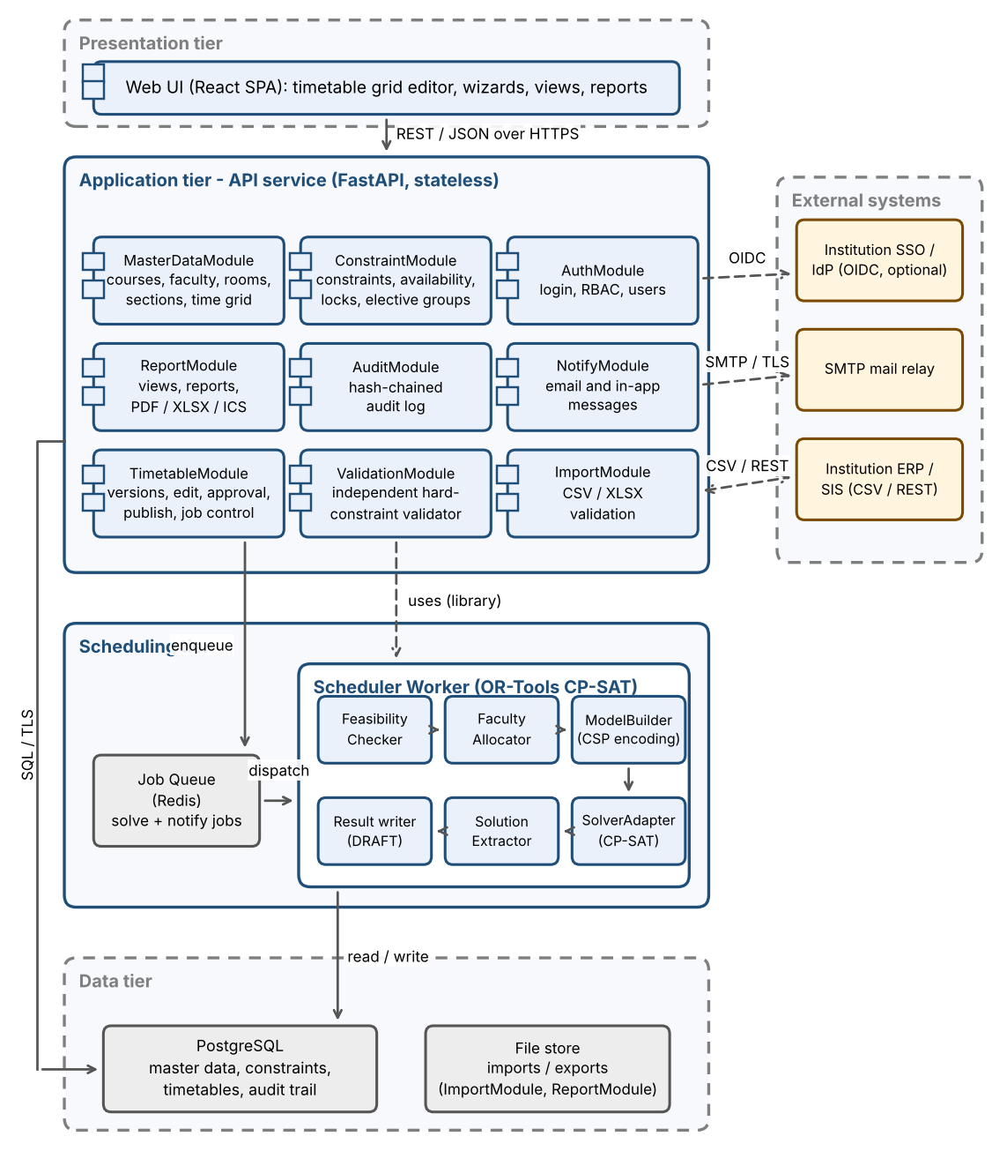
Figure 1: CTGS component diagram (logical architecture)

3.4 Component Descriptions
Component | Responsibility | Requirements
Web UI (React SPA) | Role-based screens: data, constraints, generation wizard with progress, timetable grid editor with drag-and-drop and keyboard alternative, views, reports. | TT-F-040, TT-F-050 to 054, NF-006, NF-007
AuthModule | Login (local or OIDC), sessions, RBAC and department scoping, lockout, user and role administration. | TT-F-001 to 004, SR-002, 003, 005
MasterDataModule | CRUD for academic structure, courses, faculty and qualifications, rooms, sections, lab batches (auto-split), time grid, offerings and teaching assignments. | TT-F-010 to 015, 017
ImportModule | CSV/XLSX upload, validation, preview and atomic commit; file safety checks. | TT-F-016, SR-007
ConstraintModule | Constraint catalogue and weights, availability and blocked windows, locked sessions, elective groups and combined classes. | TT-F-020 to 025
TimetableModule | Timetable versions and status workflow, job control (submit, status, cancel), manual edit with optimistic locking, substitution, approval and publish. | TT-F-037, 038, 040, 042 to 044
ValidationModule | Independent evaluator of HC-01..HC-11 on any timetable or proposed move; produces conflict reports. | TT-F-032, 041, NF-003
ReportModule | Timetable views for section, faculty and room; reports; PDF, XLSX and ICS export. | TT-F-050 to 054
NotifyModule | Email and in-app notifications with retry and de-duplication. | TT-F-055
AuditModule | Append-only, hash-chained audit trail; retention; verification. | TT-F-060, NF-012, SR-008
Job Queue (Redis) | Decouples API from solver; FIFO per quota; carries notification jobs. | TT-F-037, NF-005, SR-006
Scheduler Worker | FeasibilityChecker (necessary-condition checks), FacultyAllocator (assignment model), ModelBuilder (CSP encoding with domain pruning), SolverAdapter (OR-Tools CP-SAT with time limit, seed, hints), SolutionExtractor and result writer (calls ValidationModule, stores DRAFT version and score report). | TT-F-030 to 038, NF-001, NF-008
PostgreSQL | System of record: master data, constraints, timetables and sessions, jobs, audit trail; unique indexes on occupied slots as defence in depth. | All
File store | Uploaded imports and generated exports (encrypted, expiring links). | TT-F-016, 053

3.5 Chosen Architecture Pattern and Rationale
Pattern: layered architecture (presentation, application/API, scheduling domain, data) deployed as a modular monolith API plus separate worker processes that consume jobs from a queue. Layers depend only downwards; modules communicate through interfaces; the scheduling engine has no knowledge of HTTP or the UI. The decisions are recorded as ADRs:
ADR | Decision | Alternatives rejected | Rationale / consequence
ADR-01 | Layered modular monolith + queue-fed workers | Microservices; single process doing solving inside API requests | Microservices add deployment and consistency overhead that a small team and one database do not need. Solving inside requests would block users and break timeouts. Workers scale independently when needed.
ADR-02 | OR-Tools CP-SAT as solver | Genetic algorithm / simulated annealing; hand-written backtracking; MILP | CP-SAT handles combinatorial scheduling well, treats hard constraints exactly (feasible or proven infeasible), optimises soft constraints, supports time limits, hints, seeds and unsat cores for explanations. Metaheuristics only penalise violations, so cannot guarantee zero violations.
ADR-03 | PostgreSQL relational store | Document database | Strongly relational data with integrity rules; unique indexes on (timetable, faculty/room, day, period) block double-booking even if application code fails.
ADR-04 | Asynchronous generation via Redis job queue | Synchronous request / response | Runs last minutes; needs progress, cancel, quotas and retry; API remains responsive.
ADR-05 | Independent validator separate from the CSP encoding | Trust the solver output | A bug in the model must not reach users; validator is a simple direct check of the final assignment and also gates manual edits and publishing.
ADR-06 | React SPA + REST/JSON (OpenAPI 3) | Server-rendered pages | Interactive grid editor with instant conflict feedback; API reusable for exports and future mobile client.

3.6 Technology Stack & Data Stores
Layer | Technology | Purpose
Frontend | React 18, TypeScript, Vite, dnd-kit, axe-core in CI | SPA, drag-and-drop grid with keyboard alternative, accessibility checks
API service | Python 3.12, FastAPI, Pydantic, SQLAlchemy 2, Alembic | REST API, validation, ORM and migrations, OpenAPI documentation
Scheduling engine | Python, Google OR-Tools CP-SAT | Model building and solving; runs in worker processes (Celery/RQ workers)
Queue | Redis 7 | Job queue, rate-limit counters, short-lived cache
Database | PostgreSQL 16 (primary + streaming replica) | System of record; TLS; encryption at rest
Documents | openpyxl (XLSX), ReportLab/WeasyPrint (PDF), icalendar (ICS) | Import and export
Edge and runtime | Nginx reverse proxy (TLS, rate limit), Docker containers | Deployment, TLS termination, WAF rules
Observability | Prometheus, Grafana, structured JSON logs to a central store | Metrics, dashboards, alerting
Quality | pytest, Hypothesis, Playwright, Locust/JMeter, OWASP ZAP, pip-audit, gitleaks | Test and security tooling (see STP)

Data stores. PostgreSQL holds all durable data. Redis holds only transient data (queue, counters) and can be rebuilt. Imported and exported files are stored in an encrypted file store with expiry. A derived table session_slot holds one row per occupied period of every session so that unique indexes can enforce faculty and room exclusivity even for multi-period lab blocks.
Availability, scalability and recovery. The API is stateless and runs as two or more instances behind the reverse proxy; scheduling workers scale horizontally (N nodes, 8 vCPU / 16 GB each); the database uses a streaming replica and nightly backups plus WAL archiving (RPO <= 24 h, RTO <= 4 h); health probes run every minute (TT-NF-004, TT-NF-005, TT-NF-010).
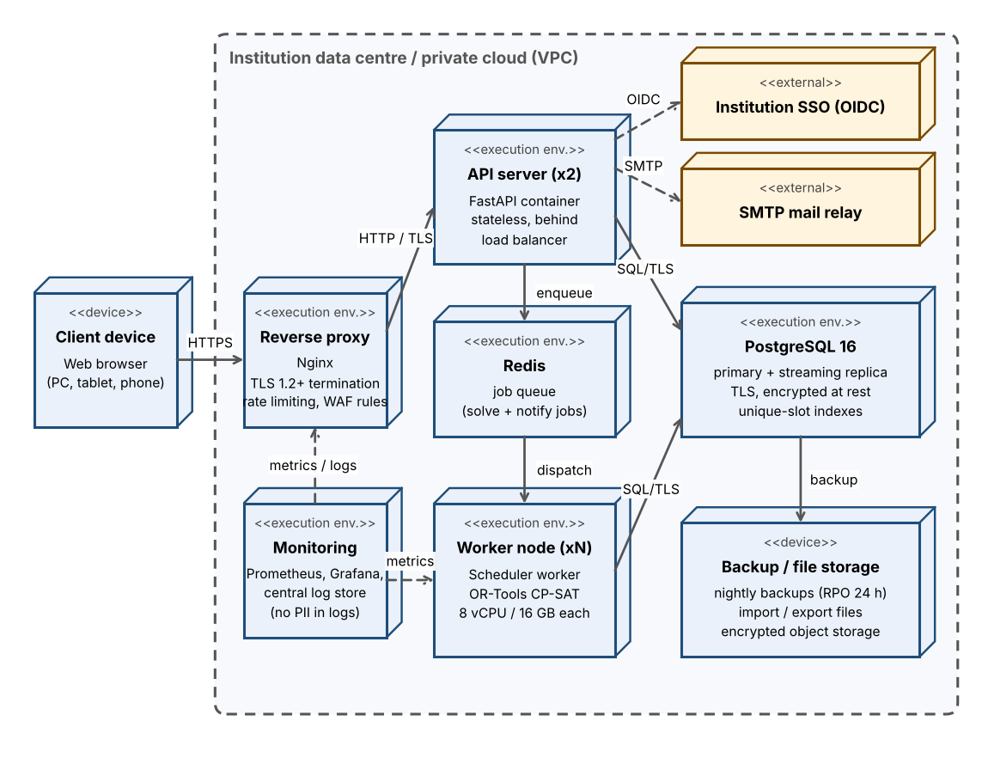
Figure 2: CTGS deployment view

3.7 Risks & Mitigations
Risk | Impact | Mitigation
Solver time grows too much for the institution-wide dataset | High | Domain pruning and symmetry breaking; decomposition by department with shared-resource reservation and repair; time limit with best partial result (TT-F-036); benchmark on S/M/L datasets.
Input data is inconsistent or infeasible (hours exceed slots, no suitable lab) | High | Feasibility pre-check with remedies (TT-F-030); unsat-core explanations; import validation with row-level report.
Coordinators distrust a 'black box' | Medium | Score breakdown per soft constraint, conflict explanations, manual edit with live checking, locked sessions, alternatives for comparison.
Concurrent edits overwrite each other | Medium | Optimistic locking with version numbers; 409 on conflict; audit trail.
Last-minute changes after publishing | Medium | Substitution suggestions with minimal change; change requests; targeted notifications.
Bug in model lets an invalid timetable through | High | Independent validator gate before save and publish; property-based tests with 200 random instances; DB unique indexes.
Leakage or misuse of personal data | High | RBAC with department scope, object-level checks, data minimisation, audit, TLS (section 3.9).
Non-reproducible results complicate debugging | Low | Reproducible mode: fixed seed, deterministic search, stable input ordering (TT-NF-008).
Vulnerable third-party dependency | Medium | Dependency and secret scanning in CI; pinned versions; patch process.

3.8 Traceability to Requirements
Each requirement is realised by one or more design specifications (DS ids). The table lists the design elements, the components that implement them, the section of this document where they are specified, and the requirements they satisfy (F = TT-F, NF = TT-NF, SR = TT-SR). The full matrix with test cases is SRS section 8.
Design spec | Design element | Component(s) | SAD section | Requirements
DS-Auth-01 | Authentication, sessions and lockout | AuthModule | 3.9, 4.3 | F-001, F-003, SR-005
DS-Auth-02 | Role-based access control and department scoping | AuthModule | 3.9 | F-002, SR-003
DS-Auth-03 | User and role administration | AuthModule | 4.3 | F-004
DS-Data-01 | Master-data model and CRUD services | MasterDataModule | 4.1.2, 4.3 | F-010, F-011, F-012, F-013, F-015
DS-Data-02 | Lab-batch auto-splitting algorithm | MasterDataModule | 4.1.5 | F-014
DS-Data-03 | Bulk import pipeline | ImportModule | 4.1.5 | F-016
DS-Data-04 | Course offerings and teaching assignments | MasterDataModule | 4.1.2 | F-017
DS-Cons-01 | Constraint catalogue and weights | ConstraintModule | 4.1.3 | F-020, F-021
DS-Cons-02 | Availability and blocked-window constraints | ConstraintModule | 4.1.3 | F-022, F-023
DS-Cons-03 | Locked sessions | ConstraintModule | 4.1.3 | F-024
DS-Cons-04 | Elective groups and combined classes | ConstraintModule | 4.1.3 | F-025
DS-Gen-01 | Feasibility pre-check | SchedulerEngine | 4.1.4 | F-030
DS-Gen-02 | Faculty allocation phase | SchedulerEngine | 4.1.5 | F-035
DS-Gen-03 | CSP model and solve | SchedulerEngine, ValidationModule | 4.1.3 | F-031, F-032
DS-Gen-04 | Lab block and batch modelling | SchedulerEngine | 4.1.3 | F-033
DS-Gen-05 | Objective function and score breakdown | SchedulerEngine | 4.1.3 | F-034
DS-Gen-06 | Infeasibility diagnosis and partial results | SchedulerEngine | 4.1.5 | F-036
DS-Gen-07 | Asynchronous job orchestration | SchedulerEngine | 4.1.4, 4.2 | F-037
DS-Gen-08 | Incremental regeneration and alternatives | SchedulerEngine | 4.1.4 | F-038
DS-Gen-09 | Reproducible mode | SchedulerEngine | 4.1.4 | NF-008
DS-Val-01 | Independent constraint validator | SchedulerEngine, ValidationModule | 3.4, 4.1.4 | F-032, F-041, NF-003
DS-Edit-01 | Manual edit with conflict check | TimetableModule | 4.2 | F-040
DS-Edit-02 | Disruption handling (substitution) | TimetableModule | 4.1.5 | F-042
DS-Edit-03 | Timetable versioning | TimetableModule | 4.1.2 | F-043
DS-Edit-04 | Approval and publish workflow | TimetableModule | 4.2 | F-044
DS-Rep-01 | Timetable views | ReportModule | 4.3, 4.5 | F-050, F-051, F-052
DS-Rep-02 | Export (PDF, XLSX, ICS) | ReportModule | 4.3 | F-053
DS-Rep-03 | Reports | ReportModule | 4.3 | F-054
DS-Ntf-01 | Notification service | NotifyModule | 4.2 | F-055
DS-Aud-01 | Audit trail and retention | AuditModule | 4.4 | F-060, NF-012, SR-008
DS-Ops-01 | Backup, restore and term cloning | Platform (Ops) | 3.6 | F-061, NF-010
DS-Ops-02 | Availability and monitoring design | Platform (Ops) | 3.6, 4.4 | NF-004
DS-Perf-01 | Solver performance strategy | SchedulerEngine | 4.1.4 | NF-001
DS-Perf-02 | API and UI performance design | API, WebUI | 3.6, 4.3 | NF-002
DS-Perf-03 | Scalability design (stateless API, worker pool) | Platform | 3.6 | NF-005
DS-UX-01 | Task-oriented workflow design | WebUI | 4.5 | NF-006
DS-UX-02 | Accessible UI design | WebUI | 4.5 | NF-007
DS-UX-03 | Responsive and cross-browser design | WebUI | 4.5 | NF-011
DS-Arch-01 | Layered architecture and quality gates | All modules | 3.5 | NF-009
DS-Sec-01 | Transport security | Platform | 3.9 | SR-001
DS-Sec-02 | Credential storage | AuthModule | 3.9 | SR-002
DS-Sec-03 | Input validation and web hardening | API, WebUI | 3.9 | SR-004
DS-Sec-04 | Rate limits and solver quotas | Platform | 3.9 | SR-006
DS-Sec-05 | Upload and spreadsheet safety | ImportModule | 3.9 | SR-007
DS-Sec-06 | Secrets and dependency hygiene | Platform | 3.9 | SR-009
DS-Sec-07 | Privacy and data minimisation | AuthModule, ReportModule | 3.9 | SR-010

Examples: TT-F-031 (automatic generation) -> SchedulerEngine, DS-Gen-03, section 4.1.3; TT-F-001 (authenticate user) -> AuthModule, DS-Auth-01, section 3.9; TT-F-040 (manual edit with conflict check) -> TimetableModule + ValidationModule, DS-Edit-01, section 4.2 (SD-2).

3.9 Security Architecture
Trust boundaries. (1) Browser to reverse proxy (untrusted network, TLS 1.2+); (2) API and workers inside the private network; (3) database and Redis in a restricted data subnet reachable only from API and workers with least-privilege accounts (workers use a role that cannot change users or audit data); (4) outbound links to SMTP and SSO over TLS. Data classification: personal data (names, emails, faculty preferences, student sections) is *confidential*; timetables are *internal* until published; credentials and tokens are *secret*.
Authentication and sessions (TT-F-001, TT-F-003, TT-SR-002, TT-SR-005). Local accounts use Argon2id password hashes; SSO uses OIDC with the authorisation-code flow and PKCE. A short-lived access token (<= 30 min) is held in an HttpOnly, Secure, SameSite cookie with CSRF protection; roles are re-read from the database on privilege change; tokens are revoked at logout. Five failed logins lock the account for 15 minutes and raise an audit event.
Authorisation (TT-F-002, TT-SR-003, TT-SR-010). Every endpoint declares the permission it needs (deny by default). Object-level checks verify department scope and, for students, section membership, before data is returned; unauthorised object ids return 404 to avoid disclosing existence.
Table 1: Role / permission matrix (Y = allowed, D = own departments only, R = read published only, O = own data only, - = none)
Operation | Admin | Coord. | HoD | Faculty | Student
Manage users and roles | Y | - | - | - | -
Master data and constraints | Y | D | R | - | -
Availability and preferences | Y | D | - | O | -
Run feasibility check / generate | Y | D | - | - | -
Edit timetable, versions, substitution | Y | D | - | - | -
Submit for approval | Y | D | - | - | -
Approve and publish | Y | - | D | - | -
View draft timetables | Y | D | D | - | -
View published timetables | Y | D | D | O | O
Reports | Y | D | D | - | -
Export (no contact data unless Admin) | Y | D | D | O | O
Audit log, backup, term cloning | Y | - | - | - | -

Threat modelling (STRIDE).
Threat | Example in CTGS | Mitigation | Requirement
Spoofing | Stolen coordinator credentials; forged token | Argon2id, lockout, optional SSO and MFA at the IdP, signed short-lived tokens, secure cookies | TT-F-001, 003, SR-002, 005
Tampering | Altered sessions in database, edited audit rows, modified uploads | Validator gate, unique slot indexes, hash-chained audit log, TLS, upload validation | TT-F-032, SR-001, 007, 008
Repudiation | A user denies publishing or editing a timetable | Audit trail with user, time, before/after values; approval workflow | TT-F-060, 044, SR-008
Information disclosure | Student reads other sections; faculty preferences leak; PII in logs | RBAC and object-level checks, data minimisation, no PII/secrets in logs, TLS, encryption at rest | TT-F-002, SR-003, 010
Denial of service | Flood of generation jobs, giant uploads, login flood | Rate limits, per-user job quota (2), worker CPU/memory/time limits, 10 MB upload limit | SR-006, 007, TT-NF-005
Elevation of privilege | Student calls admin API; IDOR across departments; SQL/XSS injection | Deny-by-default, department scoping, parameterised queries, output encoding, CSP, least-privilege DB roles | TT-F-002, SR-003, 004

4. Design

4.1 Design Overview

4.1.1 Design principles
- Separation of concerns: UI, API modules, scheduling engine and data access are separate layers with narrow interfaces.
- Validate before save: nothing reaches a DRAFT or PUBLISHED version unless the independent validator reports zero hard violations.
- Constraints as data: hard and soft constraints, weights and availability are stored configuration; the model builder reads them rather than hard-coding rules.
- Explainable results: every run stores its inputs snapshot, weights, seed, score breakdown and, on failure, the diagnostic report.
- Deny by default and least privilege for access control and database roles.
- Idempotent, observable jobs: each job has an id, a status machine, progress, a time limit and an audit entry.

4.1.2 Domain model
The figure below shows the principal entities. A *course offering* ties a course to a section in a term; a *teaching assignment* ties an offering (or one lab batch of it) to a faculty member and a kind (Lecture, Tutorial or Practical); a generated *session* places one assignment in a room at a day and start period for a number of consecutive periods. A *timetable* is a versioned set of sessions. Availability and blocked windows are modelled by *Unavailability* records (hard for 'cannot', soft for 'prefer not').
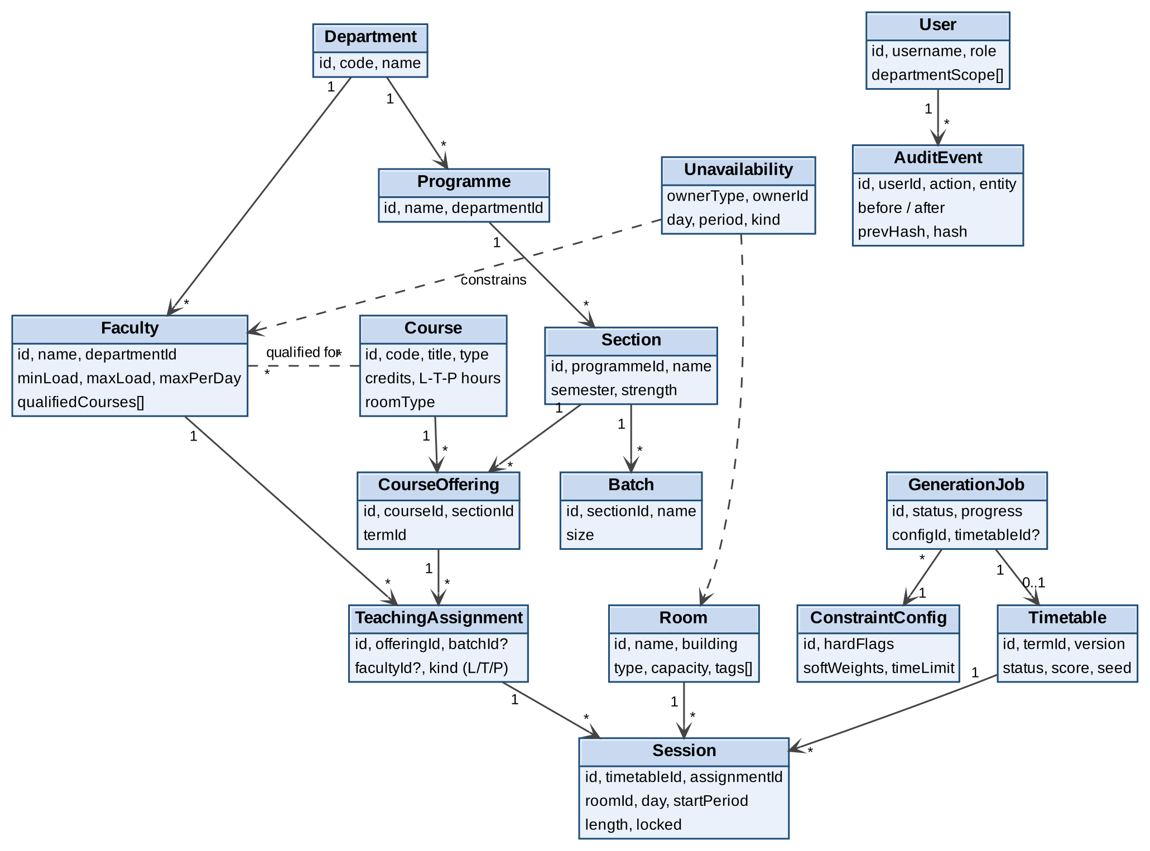
Figure 3: Domain model (UML class diagram, key attributes only)
Timetable lifecycle (TT-F-043, TT-F-044).
From | To | Trigger | Guard
(new) | DRAFT | Generation job completes or manual copy / rollback | Validator reports 0 hard violations
DRAFT | UNDER_REVIEW | Coordinator submits | Validator OK; role Coordinator/Admin in scope
UNDER_REVIEW | DRAFT | HoD rejects with comment | Role HoD/Admin
UNDER_REVIEW | PUBLISHED | HoD approves | Re-validation OK; atomic switch; previous version becomes ARCHIVED
PUBLISHED | ARCHIVED | A newer version is published | -
PUBLISHED | DRAFT (copy) | Approved change request | Creates a new draft; published version stays immutable

4.1.3 Scheduling model (CSP formulation)
The scheduling problem is formulated as a constraint satisfaction and optimisation problem and solved with OR-Tools CP-SAT.
- Events E. Every required session of a course offering is an event: each Lecture and Tutorial hour is a unit event (length 1); each practical block is a lab event of length lambda (2 or 3 periods) per batch. Number of events follows the L-T-P hours (HC-05).
- Slots S. All (day, period) cells of the time grid; a start slot is valid for an event only if all covered periods lie in the same half-day and none crosses a break (HC-06).
- Variables. x[e,s,r] is 1 if event e starts at slot s in room r. Only combinations that pass domain filtering exist: room type and capacity (HC-04), faculty availability and per-day limits (HC-07), qualification (HC-08), room availability (HC-11) and locked sessions (HC-09).
- Faculty. For events whose faculty is already assigned, f(e) is a constant. For open assignments the allocation phase (4.1.5) fixes f(e) before the timetable model is built.
Table 2: Encoding of the constraints in CP-SAT
Constraint | Encoding | HC / SC
Every event is scheduled exactly once | sum_{s,r} x[e,s,r] = 1 for each event e | HC-05
Faculty clash | For each faculty f and slot t: sum_{e: f(e)=f, s covers t, r} x[e,s,r] <= 1 | HC-01
Room clash | For each room r and slot t: sum_{e, s covers t} x[e,s,r] <= 1 (a combined class counts once) | HC-02
Section / batch clash | For each section g and slot t: events of g and of its batches overlapping t, with section events conflicting with all batches and different batches allowed in parallel: sum <= 1 per conflict group | HC-03
Suitability, availability, qualification, blocked rooms | Removed from the variable domain (no variable created for forbidden combinations) | HC-04, 07, 08, 11
Daily and weekly faculty limits | sum of periods per faculty per day <= maxPerDay; per week within [minLoad, maxLoad] | HC-07
Locked sessions | x[e,s0,r0] = 1 fixed; other events cannot use those cells | HC-09
Elective groups, combined classes | Equality of start variables: start[e1] = start[e2] for events of the group | HC-10
Objective | Minimise sum_k w_k * P_k, where P_k is the penalty of soft constraint k: idle gaps (day-occupancy booleans), same-course periods per day above 2, preference violations, daily load deviation, room changes, time-of-day mismatch | SC-01..SC-08

The objective value and each P_k are stored with the timetable and shown as the score breakdown (TT-F-034, DS-Gen-05). Lab sessions of different batches of one section are created as parallel events that require different labs (HC-02, HC-03) and are given a rotation order so that every batch gets every practical (TT-F-033, DS-Gen-04).

4.1.4 Solver pipeline and strategy
- Snapshot. The worker reads an immutable snapshot of master data, constraint configuration and weights for the term (so edits during a run do not affect it).
- Feasibility pre-check (DS-Gen-01). Necessary-condition checks: required periods per section <= available slots; per-faculty demand <= min(max load, free slots); per room type and capacity, aggregate demand <= supply; lab categories have enough labs and block-compatible slots. Errors stop the run with remedies; warnings continue.
- Faculty allocation (DS-Gen-02) for open teaching assignments (4.1.5).
- Model build and pruning. Variables are created only for valid combinations; identical rooms and identical batches get symmetry-breaking order constraints; a hint from the previous version is used for regeneration.
- Solve (DS-Gen-03, DS-Perf-01). CP-SAT with the configured time limit, seed and 8 workers; first feasible solution is kept and improved. For the Large dataset the problem is decomposed by department (priority order, shared faculty and rooms reserved), followed by a global improvement and repair stage using large-neighbourhood search.
- Independent validation (DS-Val-01). The extracted assignment is checked by the ValidationModule against HC-01..HC-11. Any violation sets the job to FAILED_VALIDATION and is logged as a defect.
- Persist. Sessions, session_slot rows, score breakdown, seed and solver version are stored in one transaction as a DRAFT version; the job becomes DONE.
Job states (DS-Gen-07): QUEUED, RUNNING, DONE, PARTIAL (time limit reached with unscheduled sessions), INFEASIBLE (with explanation), FAILED, FAILED_VALIDATION, CANCELLED. Cancellation sets a flag that the solver callback checks, stopping within 10 s. Regeneration (DS-Gen-08): locked and published sessions are fixed and only the rest is re-solved; alternatives are produced by re-solving with a different seed and a no-good constraint that forces at least one session to differ. Reproducible mode (DS-Gen-09): fixed seed, deterministic search (single worker or interleaved search) and stable ordering of all inputs.

4.1.5 Supporting algorithms
Lab batch splitting (DS-Data-02). For a section of n students and a lab capacity limit c: number of batches k = ceil(n / c); batch sizes are floor(n/k) or ceil(n/k) so they differ by at most 1. Example n = 62, c = 30: k = 3, sizes 21, 21, 20; n = 31: k = 2, sizes 16, 15.
Faculty allocation (DS-Gen-02). A small CP-SAT model with Boolean y[a,f] for each open assignment a and qualified faculty f: each assignment gets exactly one faculty; weekly load within [minLoad, maxLoad]; minimise the difference between the most and least loaded faculty of a department plus preference penalties. Output is a list of fixed assignments.
Infeasibility diagnosis (DS-Gen-06). Each family of hard constraints gets an assumption literal. When the solver proves infeasibility, the unsat core is mapped to readable messages (for example 'Sections 5A and 5B both need Lab-3 for 8 periods but Lab-3 has 6 free block starts'), together with suggested remedies such as adding a lab, relaxing availability or reducing hours. When the time limit is reached, the best partial solution (maximising scheduled events) is returned with the unscheduled list.
Import pipeline (DS-Data-03, TT-SR-007). Upload -> type/size/content check -> parse -> row validation (types, ranges, duplicates) -> referential checks -> preview -> commit in one transaction (atomic mode) or row by row (non-atomic mode) -> error report. Cells beginning with = + - @ are neutralised on import and export.
Disruption handling (DS-Edit-02). For an unavailable faculty member or room, affected sessions are listed; candidates are ranked by hard filters (qualified, free in the slot, room suitable) then by load headroom, preference and same department. The change is applied with a local re-solve restricted to the affected sessions, so the rest of the timetable is untouched.

4.1.6 Data design notes
- Main tables: users, departments, programmes, sections, batches, courses, offerings, faculty, faculty_qualification, rooms, unavailability, constraint_config, teaching_assignment, timetable, session, session_slot, generation_job, notification, audit_event.
- session_slot has one row per occupied period with unique indexes (timetable_id, faculty_id, day, period) and (timetable_id, room_id, day, period) (defence in depth for HC-01, HC-02).
- Optimistic locking: version column on timetable and session; updates use WHERE version = :v.
- Audit hash chain: hash_n = SHA-256(hash_{n-1} || canonical_json(event_n)); verification recomputes the chain (TT-SR-008, TT-NF-012).
- Soft delete for master data referenced by archived timetables; term cloning copies master data and configuration with new identifiers (TT-F-061).

4.2 UML Sequence Diagrams
Three flows that are specific to CTGS are shown: generating a timetable (SD-1), manual editing with conflict detection (SD-2), and approval, publishing and notification (SD-3).

SD-1 Generate a timetable (TT-F-030 to TT-F-037)
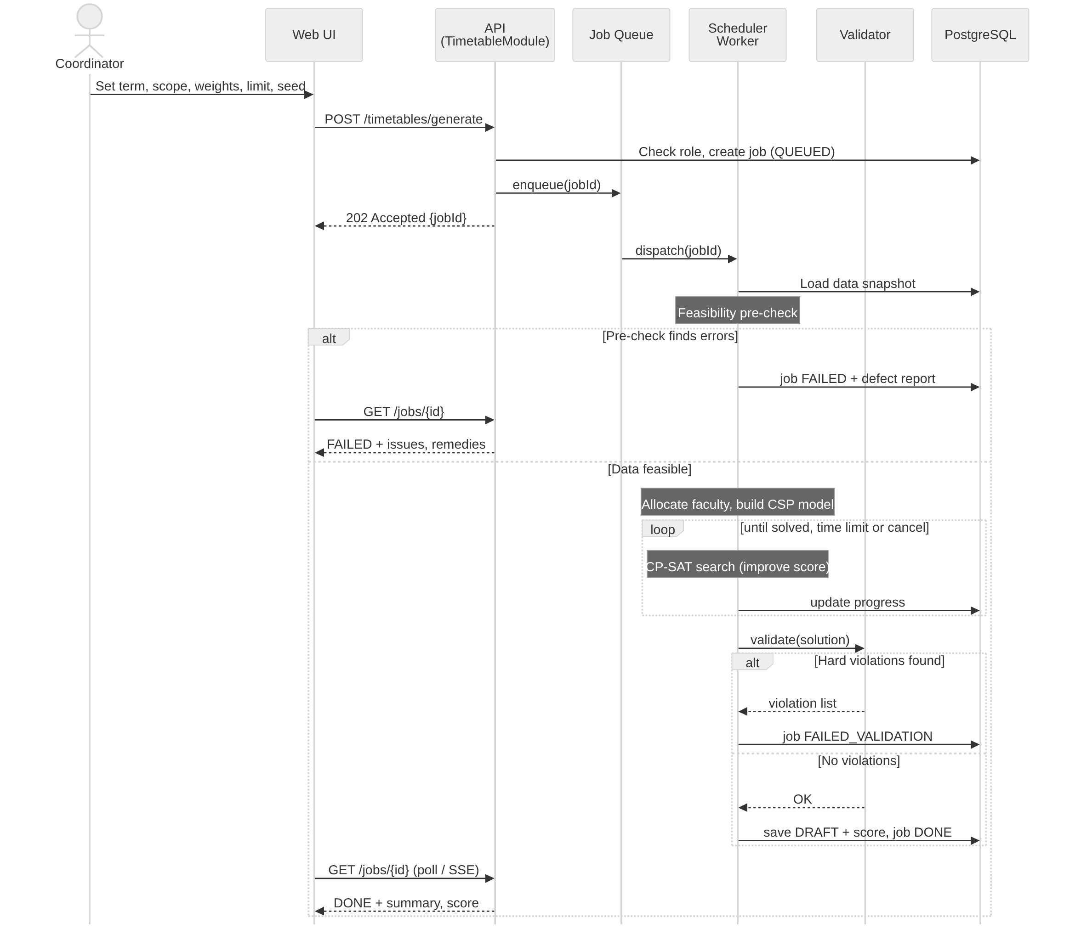
Figure 4: Sequence diagram SD-1: asynchronous timetable generation

SD-2 Manual edit with conflict detection (TT-F-040, TT-F-041)
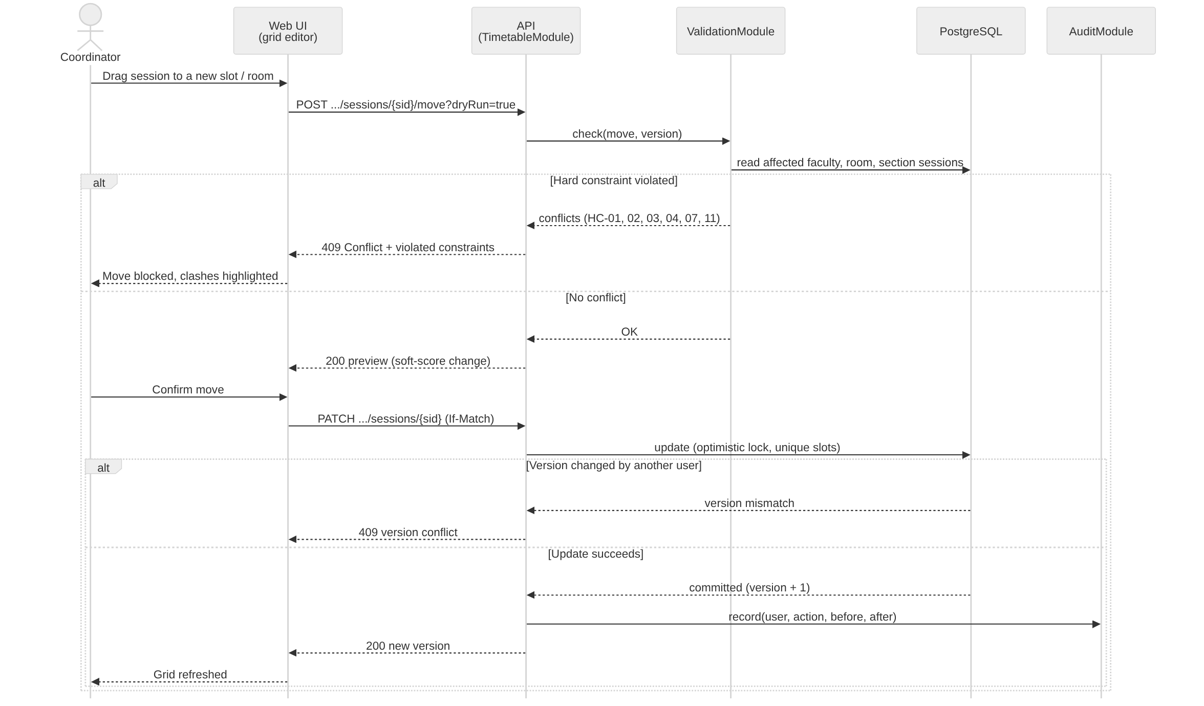
Figure 5: Sequence diagram SD-2: move a session with instant conflict check and optimistic locking

SD-3 Approve, publish and notify (TT-F-044, TT-F-055)
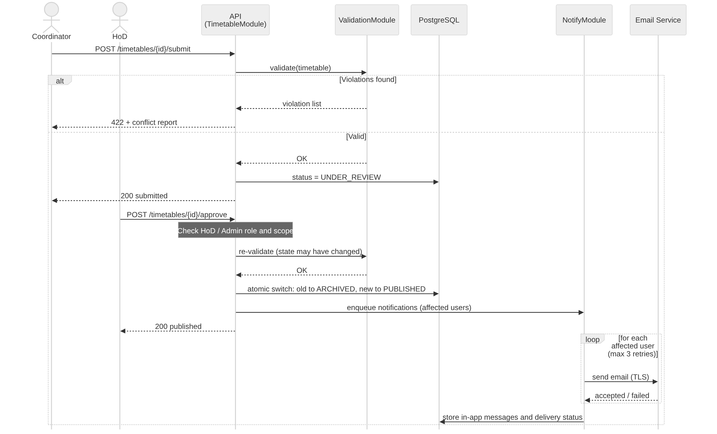
Figure 6: Sequence diagram SD-3: submit, approve, publish and send notifications

4.3 API Design
Conventions. Base path /api/v1; JSON over HTTPS; authentication by session cookie (or bearer token for tools); every state-changing call is audited. Errors use RFC 7807 application/problem+json with fields type, title, status, detail and, for constraint problems, violations[]. List endpoints support page, size, sort. Job submission accepts an Idempotency-Key header. Rate limits are returned in RateLimit-* headers.
Component 1: Auth API (AuthModule)
Endpoint | Method | Request | Response | Errors
/auth/login | POST | {username, password} or OIDC callback | {user, role, expiresAt} + cookie | 401 invalid credentials; 423 locked (15 min); 429 rate limit
/auth/logout | POST | - | 204 | 401
/users | POST | {username, role, departments[]} | 201 {id} | 400 validation; 403 not admin; 409 duplicate
/users/{id} | PATCH | {role?, departments[]?, active?} | 200 {user} | 403; 404

Component 2: Generation and Timetable API (TimetableModule)
Endpoint | Method | Request | Response | Errors
/timetables/generate | POST | {termId, scope{departments[]}, weights{SC-01..08}, optionalHC[], timeLimitSec, seed?, reproducible?, alternatives?} | 202 {jobId} | 400; 403; 422 feasibility errors {issues[]}; 429 quota (2 jobs/user)
/jobs/{id} | GET | - | {status, progress, scoreBreakdown?, timetableId?, issues[]?, unscheduled[]?} | 404
/jobs/{id}/cancel | POST | - | 202 | 404; 409 already finished
/timetables/{id}/sessions/{sid}/move | POST (dryRun) / PATCH | {day, startPeriod, roomId, facultyId?} (If-Match: version) | 200 {preview, scoreDelta} / {session, version} | 409 {violations[]} or version conflict; 403; 404
/timetables/{id}/validate | POST | - | 200 {violations[]} | 404
/timetables/{id}/submit | POST | - | 200 {status: UNDER_REVIEW} | 422 not valid; 403; 409 wrong state
/timetables/{id}/approve | POST | {comment?} | 200 {status: PUBLISHED} | 403 not HoD; 409; 422 re-validation failed
/timetables/{id}/compare/{otherId} | GET | - | {added[], removed[], moved[]} | 404
/timetables/{id}/substitutions | POST | {facultyId or roomId, from, to} | 200 {suggestions[] ranked} | 404; 422

Component 3: Views, Export and Import API (ReportModule, ImportModule)
Endpoint | Method | Request | Response | Errors
/views/section/{id} | GET | ?termId, batchId? | {grid[day][period]{course, faculty, room}} | 403; 404
/views/faculty/{id} | GET | ?termId | {grid, weeklyLoad} | 403; 404
/views/room/{id} | GET | ?termId | {grid, utilisationPct} | 403; 404
/exports | POST | {view, id, format: pdf|xlsx|ics} | 200 file (expiring link) | 400; 403; 404
/imports | POST | multipart file, {entity, atomic} | 202 {importId}; GET /imports/{id} gives preview and errors[] | 413 > 10 MB; 415 type; 422 row errors
/audit | GET | ?from, to, user?, entity? | {events[]} | 403 not admin

Example: start a generation run
POST /api/v1/timetables/generate
{
"termId": "2026-ODD", "scope": {"departments": ["CSE"]},
"weights": {"SC-01": 5, "SC-02": 4, "SC-03": 6, "SC-04": 3},
"timeLimitSec": 300, "seed": 42, "reproducible": true
}
202 Accepted {"jobId": "job_8f3a", "status": "QUEUED"}
422 Unprocessable {"title": "Feasibility errors", "issues": [{"severity": "ERROR",
"entity": "Course CS301", "detail": "needs 45 h, 40 slots/week",
"remedy": "reduce L-T-P hours or add a day"}]}
Example: move a session (conflict)
POST /api/v1/timetables/812/sessions/5531/move?dryRun=true
{"day": "WED", "startPeriod": 3, "roomId": "R-204"}
409 Conflict
{"title": "Hard constraint violated", "violations": [
{"constraint": "HC-01", "entity": "Faculty Dr. Rao", "slot": "WED P3",
"detail": "already teaches CS302 to section 5B"}]}
Table 3: Standard error codes
Code | Meaning | Typical use
400 | Validation error | Malformed or out-of-range field
401 / 403 | Not authenticated / not allowed | Missing session; role or department scope violation
404 | Not found (also returned for objects outside the caller's scope) | Prevents disclosing that an object exists
409 | Conflict | Hard-constraint violation on edit; version mismatch; invalid state transition
413 / 415 | File too large / unsupported type | Import and upload checks
422 | Business rule failed | Infeasible input; timetable not submittable; row errors in import
423 / 429 | Account locked / rate limit or quota exceeded | Login lockout; generation job quota
500 / 503 | Server error / dependency unavailable | Generic message plus correlation id; details only in logs

4.4 Error Handling, Logging & Monitoring
- Error handling. Standardised problem+json responses; user-friendly messages without stack traces; a correlation id is returned and logged; solver and validator failures set the job status and never publish partial data; database transactions are atomic (publish, import, restore).
- Logging. Structured JSON logs (timestamp, level, correlation id, user id, module). No passwords, tokens, full personal data or cookie values are logged (TT-SR-008). Security events (login failures, lockouts, authorisation denials) are logged separately.
- Audit. Every create, update, delete, generate, approve and publish writes an append-only, hash-chained audit event with before and after values; retention at least 3 years; chain verification job runs nightly (TT-F-060, TT-NF-012).
- Monitoring and alerts. Prometheus metrics with Grafana dashboards and alerts:
Metric | Alert condition | Purpose
API p95 latency / error rate | p95 > 1 s for 5 min; 5xx > 1% | TT-NF-002 health
Generation duration, success / failure rate | Median above NF-001 target; failures > 5% | Solver health, TT-NF-001
Queue depth and job age | Job waits > 10 min | Capacity of workers
FAILED_VALIDATION count | Any occurrence | Model defect (critical)
Uptime probe (1 min) | 2 consecutive failures | TT-NF-004
Backup age and restore test | Last backup > 26 h | TT-NF-010
Login failures, lockouts, 429s | Spike above baseline | Attack detection (SR-006)

4.5 UX Design
Principles. Task-oriented workflow (Data -> Constraints -> Generate -> Review/Edit -> Approve -> Publish), plain language, immediate feedback, safe undo, accessibility by default (WCAG 2.1 AA, keyboard alternative for drag-and-drop, conflicts shown by icon and text, high-contrast theme, scalable fonts) and a responsive viewing experience for phones.
Screen | Roles | Purpose and key elements | Requirements
Login | All | Local or SSO login; clear lockout message | TT-F-001, 003
Dashboard | Coordinator, HoD | Term status, data completeness, last runs, pending approvals | TT-F-043, 044
Master data grids and import wizard | Admin, Coordinator | Searchable tables, inline validation, CSV/XLSX import with preview and error report | TT-F-010 to 017
Constraint setup | Coordinator | Hard constraint list, soft weights sliders (0-10), availability, locks, electives | TT-F-020 to 025
Generate wizard | Coordinator | Scope, weights, time limit, seed; feasibility report; live progress, cancel; result summary with score breakdown | TT-F-030 to 038
Timetable grid editor | Coordinator | Days x periods grid for section/faculty/room; drag-and-drop or 'Move to...' dialog; live conflict panel; version compare | TT-F-040 to 043
Approval | HoD | Review summary, conflict report, compare with previous, approve or reject with comment | TT-F-044
My timetable | Faculty, Student | Weekly view, today view on mobile, export PDF/ICS, notifications | TT-F-050, 051, 053, 055
Reports and audit | HoD, Admin | Workload, utilisation, unscheduled sessions; audit search | TT-F-054, 060

Sample output. The section view for a section of five theory courses, an elective, tutorial, mentoring and two labs is shown below as it would appear in the My timetable screen (lunch break between P4 and P5; lab sessions occupy two consecutive periods; rooms are those allocated by the engine).
Table 4: Sample weekly timetable of section CSE-5A (P4 | lunch | P5)
Day | P1 | P2 | P3 | P4 | P5 | P6 | P7 | P8
Mon | ML  Dr. Rao  R-204 | DBMS  Dr. Iyer  R-204 | CN  Prof. Nair  R-204 | SE  Dr. Kulkarni  R-204 | DBMS Lab  Dr. Iyer  B1 Lab-2  B2 Lab-3 | DBMS Lab  Dr. Iyer  B1 Lab-2  B2 Lab-3
Tue | TOC  Prof. Das  R-204 | ML  Dr. Rao  R-204 | SE  Dr. Kulkarni  R-204 | CN  Prof. Nair  R-204 | CN Lab  Prof. Nair  B1 Lab-4  B2 Lab-5 | CN Lab  Prof. Nair  B1 Lab-4  B2 Lab-5
Wed | DBMS  Dr. Iyer  R-204 | CN  Prof. Nair  R-204 | TOC  Prof. Das  R-204 | Elective  Dr. Mehta  R-310 | SE Tutorial  Dr. Kulkarni  R-204
Thu | ML  Dr. Rao  R-204 | TOC  Prof. Das  R-204 | DBMS  Dr. Iyer  R-204 | Elective  Dr. Mehta  R-310
Fri | SE  Dr. Kulkarni  R-204 | Elective  Dr. Mehta  R-310 | Mentoring  Dr. Rao  R-204

Lab sessions (DBMS Lab, CN Lab) occupy P5-P6; the same lab block hosts one batch per lab in parallel (HC-02, HC-03, HC-06). Course hours match L-T-P (ML, DBMS, CN, SE, TOC 3 each, Elective 3, one SE tutorial, two 2-period labs).

4.6 Open Issues & Next Steps
Open issue | Next step
Real institution data may be larger or harsher than the synthetic L dataset | Benchmark on anonymised real data; tune decomposition and time limits before roll-out
Examination timetabling is out of scope | Reuse the validator and CSP framework with exam-specific constraints in version 2
Student-level elective allocation and seat limits | Add a preference-based allocation step before scheduling
Week-by-week variations (holidays, guest lectures) | Add overrides on top of the weekly pattern and calendar integration
Choice of SSO provider and MFA policy | Decide with institution IT; implement OIDC configuration
Fairness and quality metrics beyond the weighted score | Add reports on gap hours, load balance and preference satisfaction
Future enhancements | Mobile app with push notifications, learning from past timetables, automatic re-optimisation after disruptions

5. Appendices
5.1 Glossary: ADR - Architecture Decision Record; CP-SAT - constraint programming with SAT-based search (OR-Tools); CSP - Constraint Satisfaction Problem; HC / SC - hard / soft constraint; LNS - large-neighbourhood search; OIDC - OpenID Connect; PKCE - Proof Key for Code Exchange; RBAC - role-based access control; RPO / RTO - recovery point / time objective; STRIDE - threat model; unsat core - minimal set of assumptions that make a model infeasible; L-T-P - Lecture, Tutorial, Practical hours.
5.2 References: IEEE 42010 (architecture description), ISO/IEC/IEEE 29148, OWASP ASVS and Top 10, NIST SP 800-160, W3C WCAG 2.1, RFC 7807 (problem details), Google OR-Tools CP-SAT documentation, PostgreSQL documentation.
5.3 Tools: Diagrams generated with Matplotlib, Graphviz and Mermaid (sources can be redrawn in PlantUML or draw.io); API specification in OpenAPI / Swagger UI; development with Python, FastAPI, React, Docker; testing and security tools listed in the Software Test Plan.

